CS 4375

ASSIGNMENT 1

Names of students in your group:

Nikita Istomin

Number of free late days used: 2   
Note: You are allowed a **total** of 4 free late days for the **entire semester**. You can use at most 2 for each assignment. After that, there will be a penalty of 10% for each late day.

Please list clearly all the sources/references that you have used in this assignment.

Burkov, Andriy. The Hundred-Page Machine Learning Book. Andriy Burkov, 2019.

Contents

Part 1 3

Log: 3

Are you satisfied that you have found the best solution? 24

Part 2 25

Log 25

Are you satisfied that you have found the best solution? 26

# Part 1

## Log:

To assess which features will be useful for a linear model I standardized them, and graphed each of them against the label: 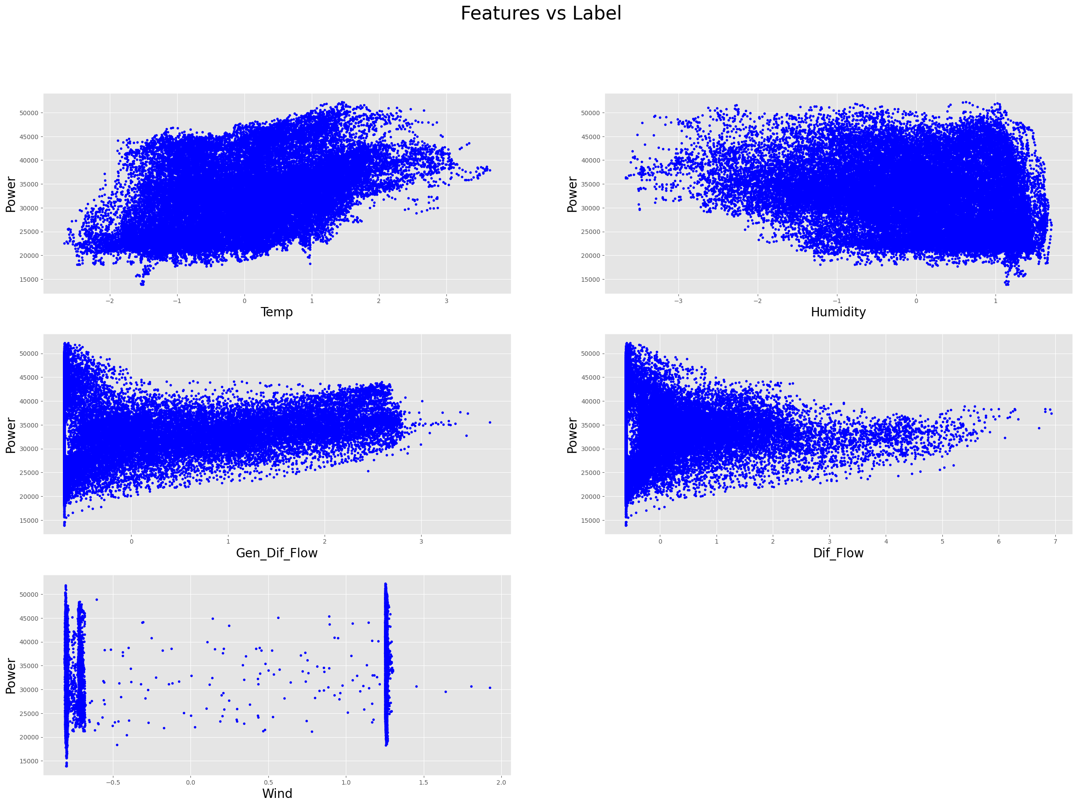

I excluded the Wind feature (3 row, 1 col) from the model due to its extreme non-linearity.

Running my algorithm on 4 remaining features over 1000 iterations with 0.01 learning rate I can see that after 200 iterations the cost doesn’t decrease much.

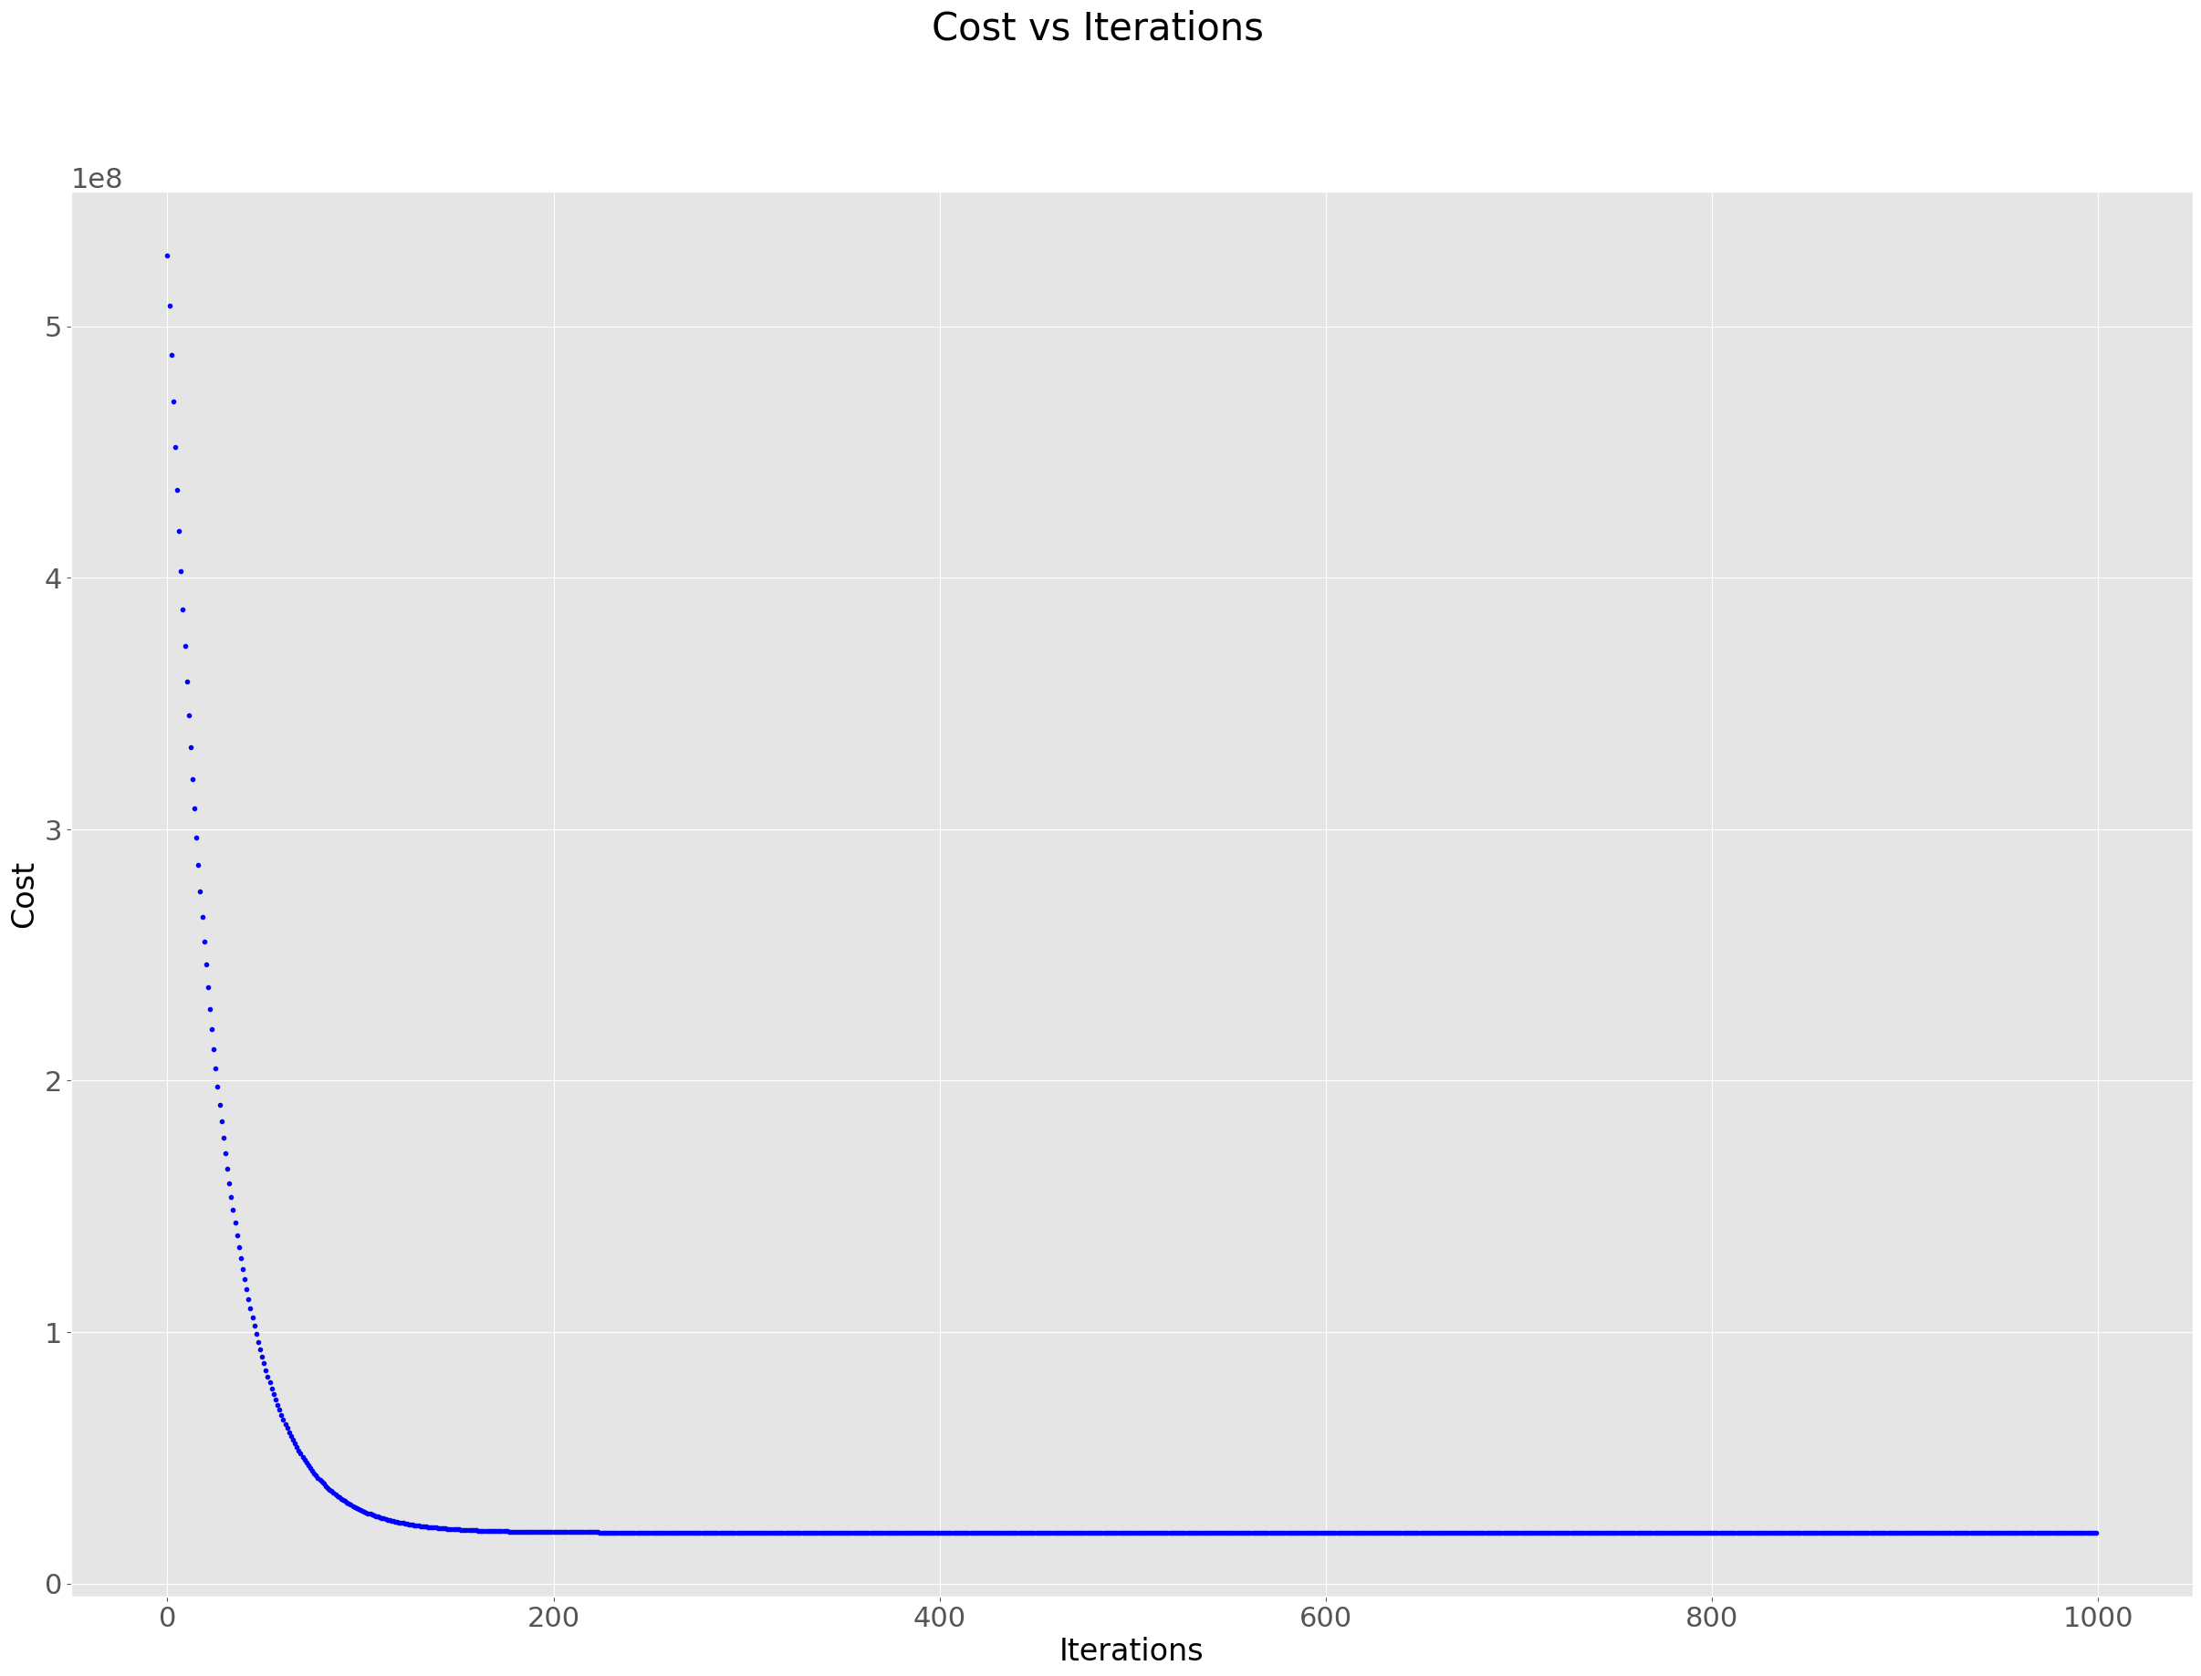

Testing combinations of all features with 200 iterations on 0.01 learning rate to see which combination gives the best results:

1 – Only Temperature

My model's performance for training set

--------------------------------------

MSE is 41448198.00130125

R2 score is 0.18743494013352524

Explained Variance score is 0.19378128356193614

--------------------------------------

My model's performance for test set

--------------------------------------

MSE is 40688502.31316514

R2 score is 0.18903438327227828

Explained Variance score is 0.19355693413151742

--------------------------------------

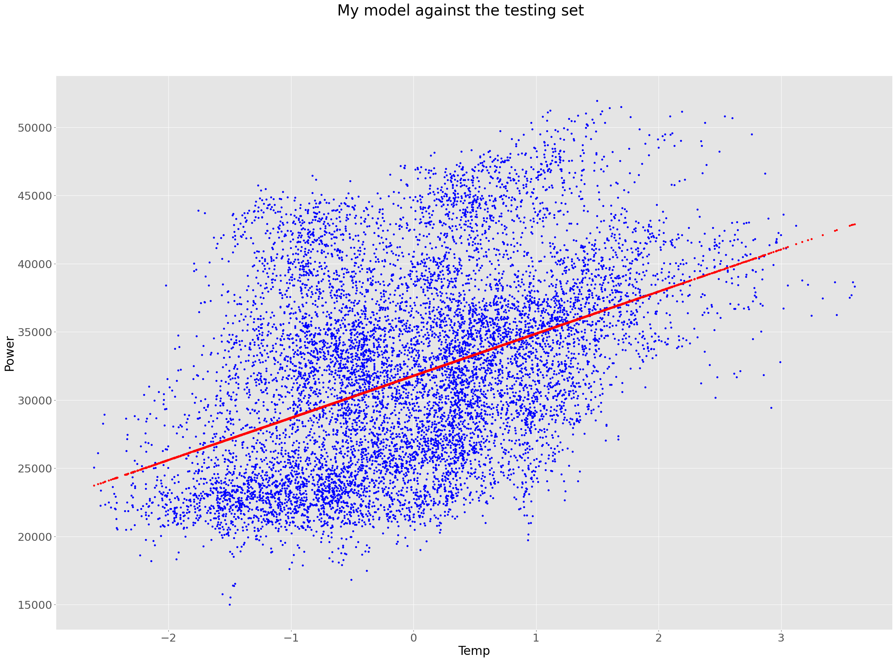 Blue dots - real data, red dots - predicted data

2 – Only Humidity

My model's performance for training set

--------------------------------------

MSE is 47118095.8939143

R2 score is 0.07628026652375142

Explained Variance score is 0.08262804967284076

--------------------------------------

My model's performance for test set

--------------------------------------

MSE is 46260591.98509396

R2 score is 0.07797664262410908

Explained Variance score is 0.08241896117953507

--------------------------------------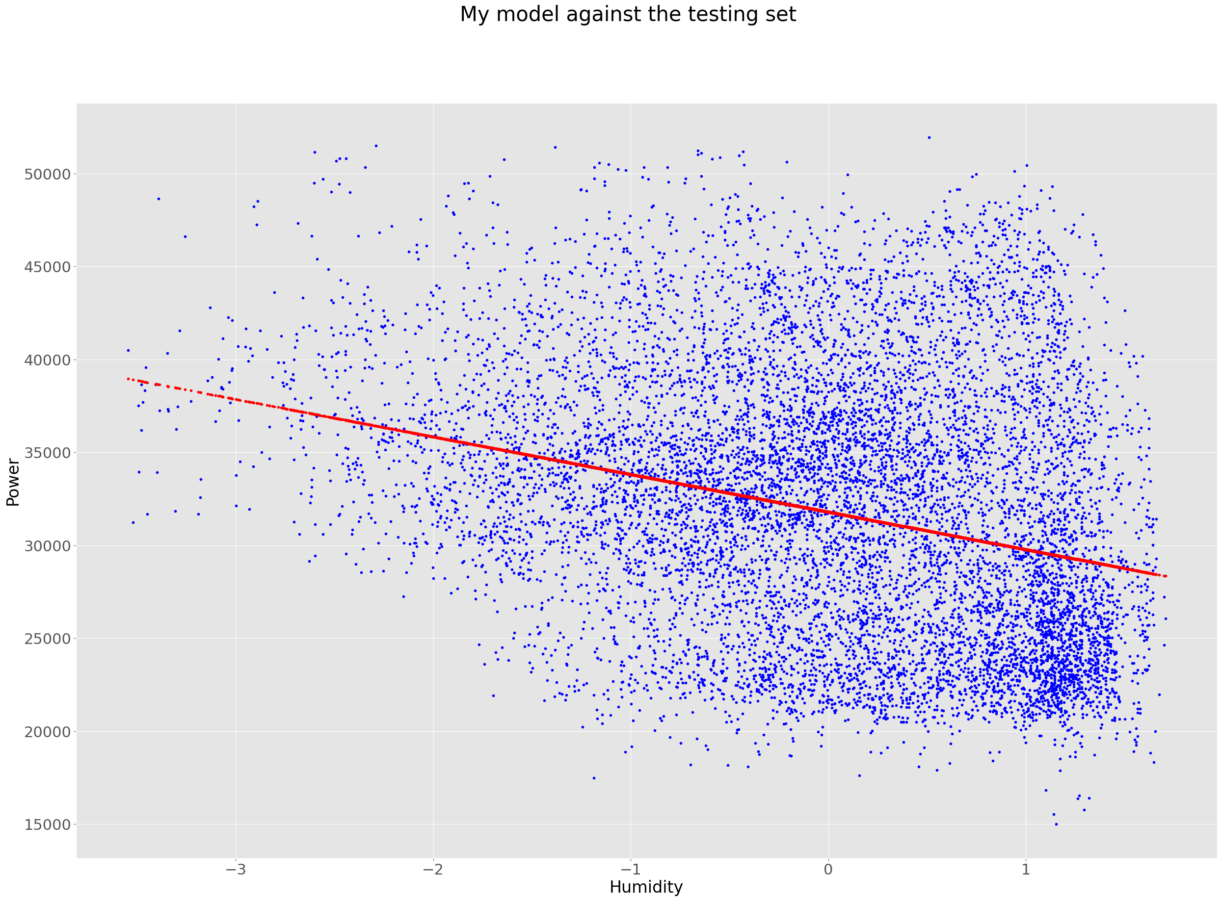

3 – Only General Diffuse Flows

My model's performance for training set

--------------------------------------

MSE is 49548794.11563662

R2 score is 0.028628003185569018

Explained Variance score is 0.034973890298841015

--------------------------------------

My model's performance for test set

--------------------------------------

MSE is 48564702.3241879

R2 score is 0.032053245204110126

Explained Variance score is 0.036650932211232945

--------------------------------------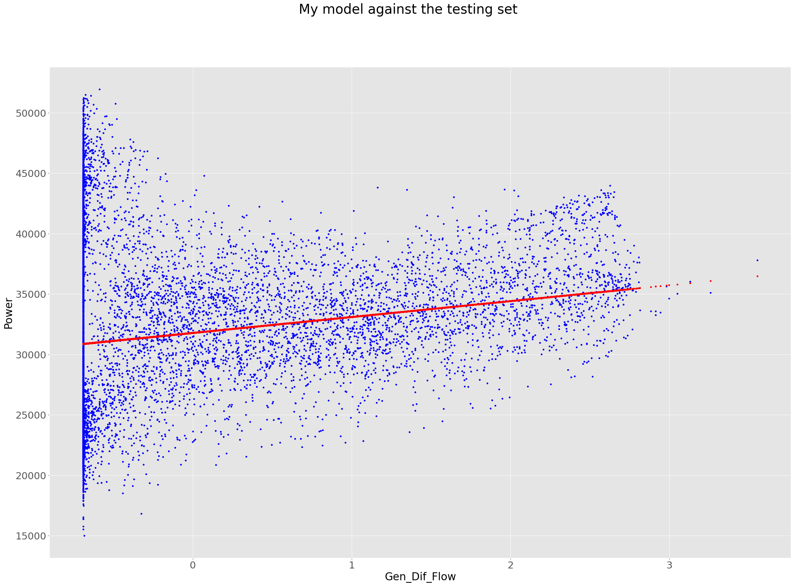

4 – Only Diffuse Flows

My model's performance for training set

--------------------------------------

MSE is 51015310.81121894

R2 score is -0.00012210620407504535

Explained Variance score is 0.006232789806965955

--------------------------------------

My model's performance for test set

--------------------------------------

MSE is 50010707.45723444

R2 score is 0.0032328075412296764

Explained Variance score is 0.007276557071894896

--------------------------------------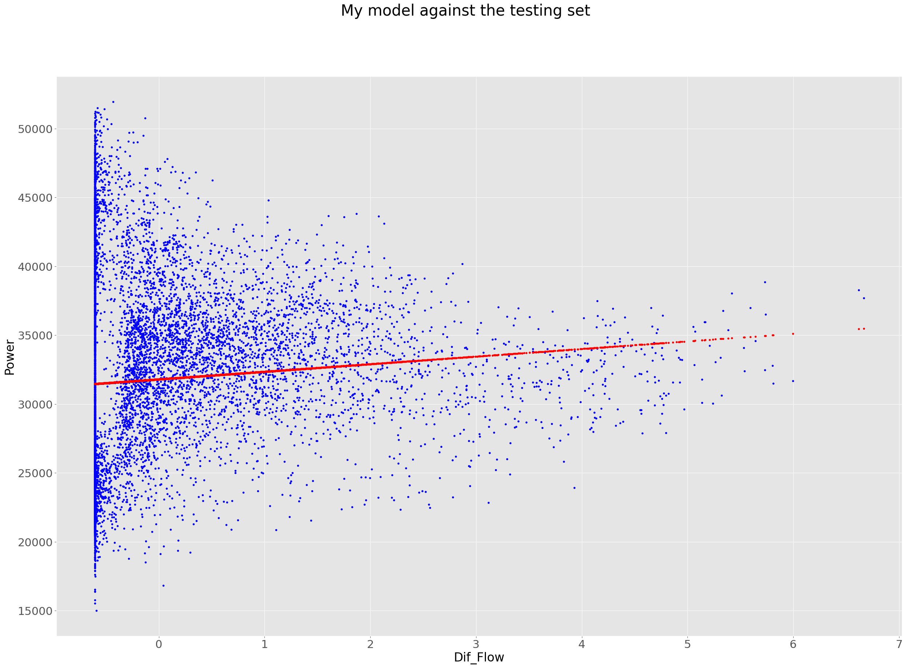

5 – Temperature and Humidity

My model's performance for training set

--------------------------------------

MSE is 41001906.82047648

R2 score is 0.19618418949904348

Explained Variance score is 0.2025327139238171

--------------------------------------

My model's performance for test set

--------------------------------------

MSE is 40217172.32876338

R2 score is 0.19842849683636898

Explained Variance score is 0.20304480576264283

--------------------------------------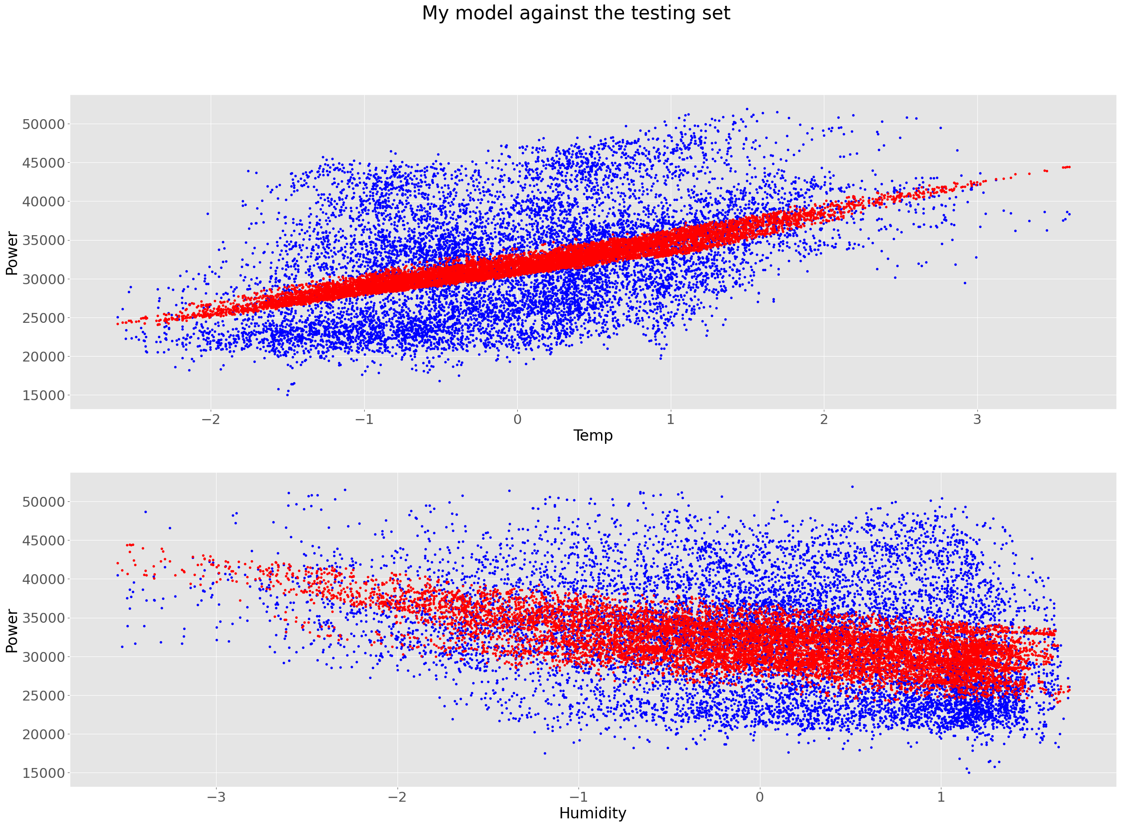

6 – Temperature and General Diffuse Flows

My model's performance for training set

--------------------------------------

MSE is 41472207.019698

R2 score is 0.18696425888773793

Explained Variance score is 0.19332055717542274

--------------------------------------

My model's performance for test set

--------------------------------------

MSE is 40707223.08039551

R2 score is 0.18866125824482594

Explained Variance score is 0.19320086124200053

--------------------------------------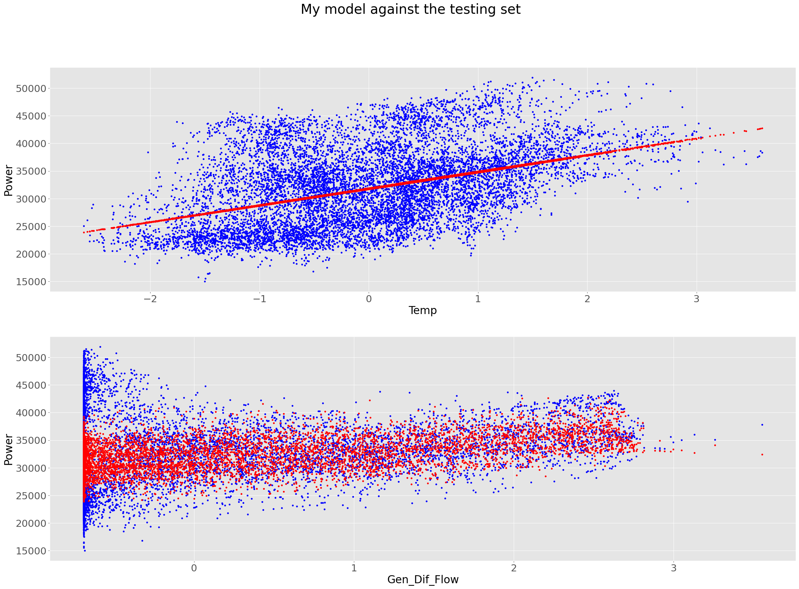

7 – Temperature and Diffuse Flows

My model's performance for training set

--------------------------------------

MSE is 41448665.120340936

R2 score is 0.18742578256748488

Explained Variance score is 0.19377049410140912

--------------------------------------

My model's performance for test set

--------------------------------------

MSE is 40689057.62099224

R2 score is 0.1890233153899804

Explained Variance score is 0.19354401755512218

--------------------------------------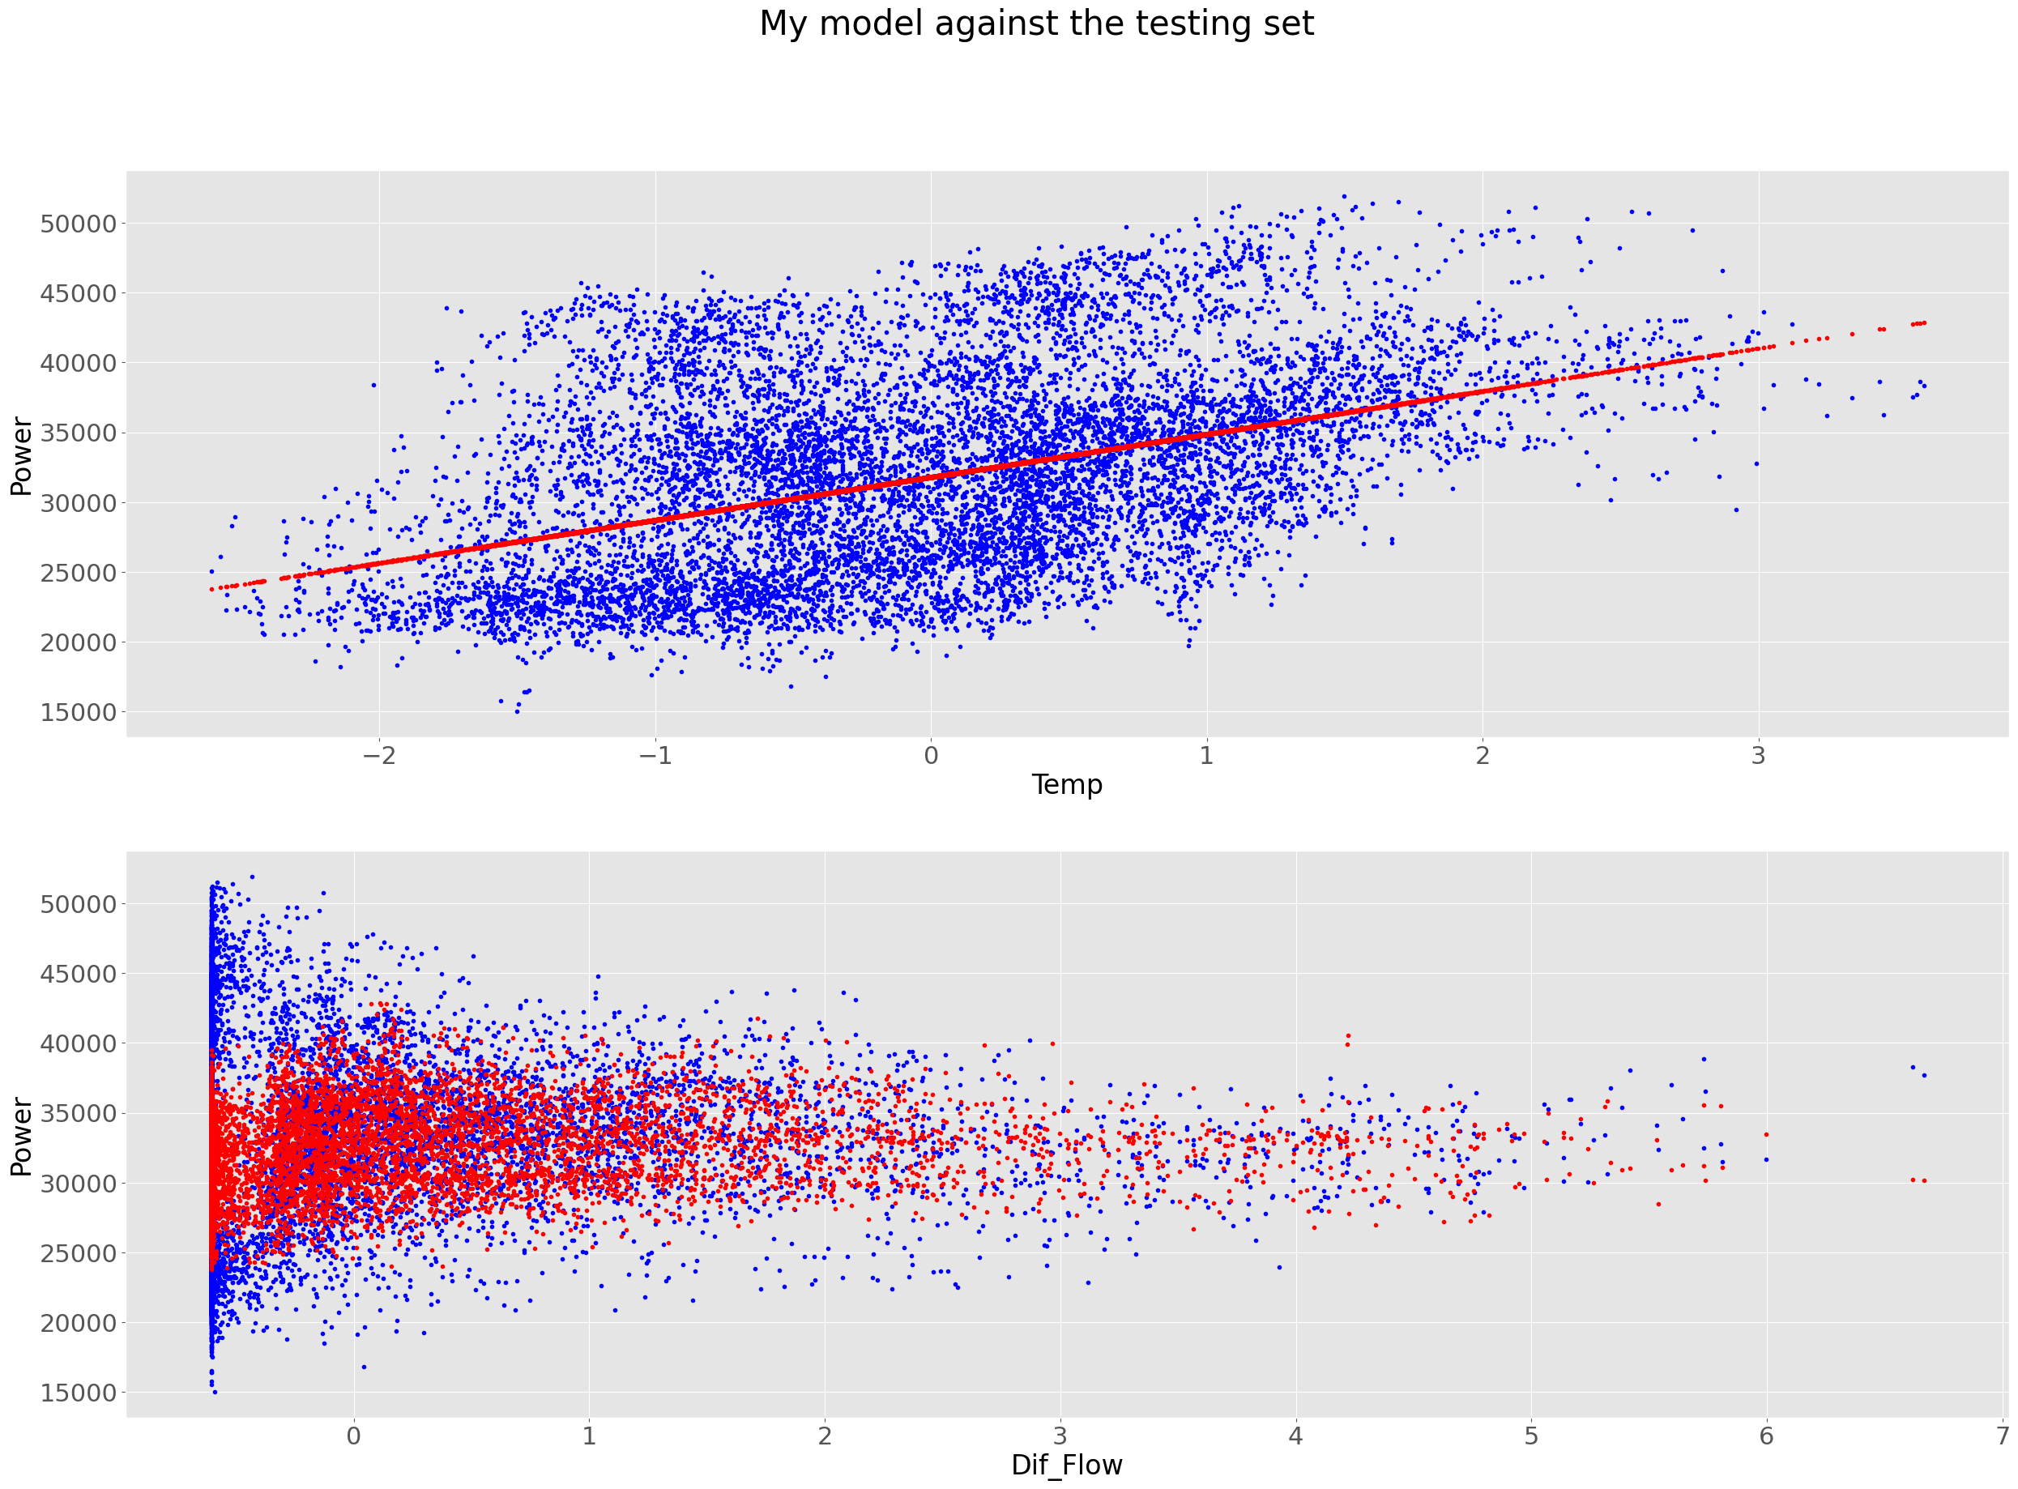

8 – Humidity and General Diffuse Flows

My model's performance for training set

--------------------------------------

MSE is 46945503.87298095

R2 score is 0.07966382123987614

Explained Variance score is 0.08601491439895381

--------------------------------------

My model's performance for test set

--------------------------------------

MSE is 46061432.614925936

R2 score is 0.08194610309262962

Explained Variance score is 0.08655860607236732

--------------------------------------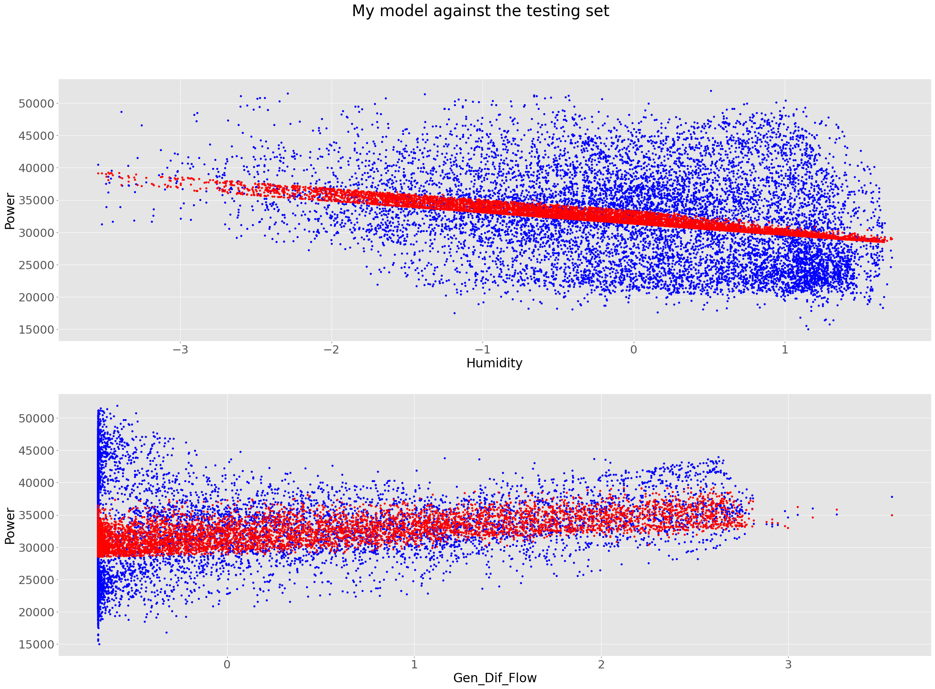

9 – Humidity and Diffuse Flows

My model's performance for training set

--------------------------------------

MSE is 47118386.73806535

R2 score is 0.0762745647126617

Explained Variance score is 0.08262118974300448

--------------------------------------

My model's performance for test set

--------------------------------------

MSE is 46253476.30543302

R2 score is 0.0781184657735644

Explained Variance score is 0.08254475712215903

--------------------------------------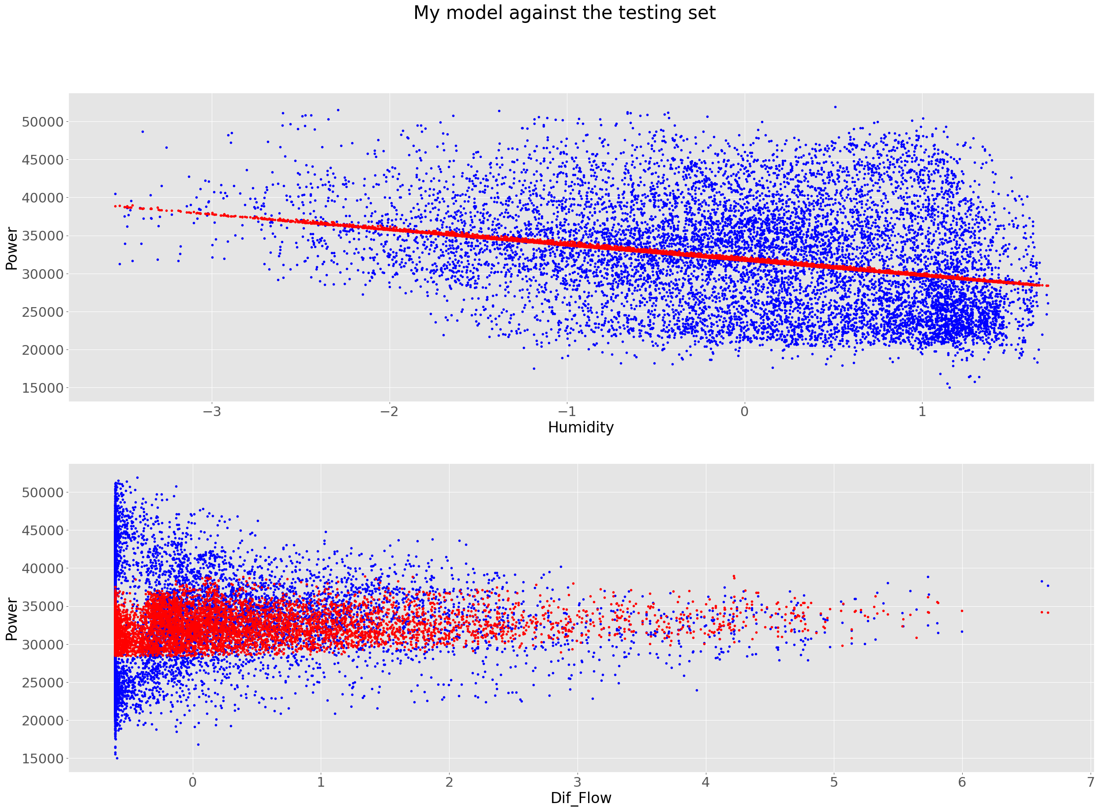

10 – General Diffuse Flows and Diffuse Flows

My model's performance for training set

--------------------------------------

MSE is 49511424.01960936

R2 score is 0.02936061969919046

Explained Variance score is 0.035700908693532374

--------------------------------------

My model's performance for test set

--------------------------------------

MSE is 48536184.67741954

R2 score is 0.03262163257853634

Explained Variance score is 0.03724981910295366

-------------------------------------- 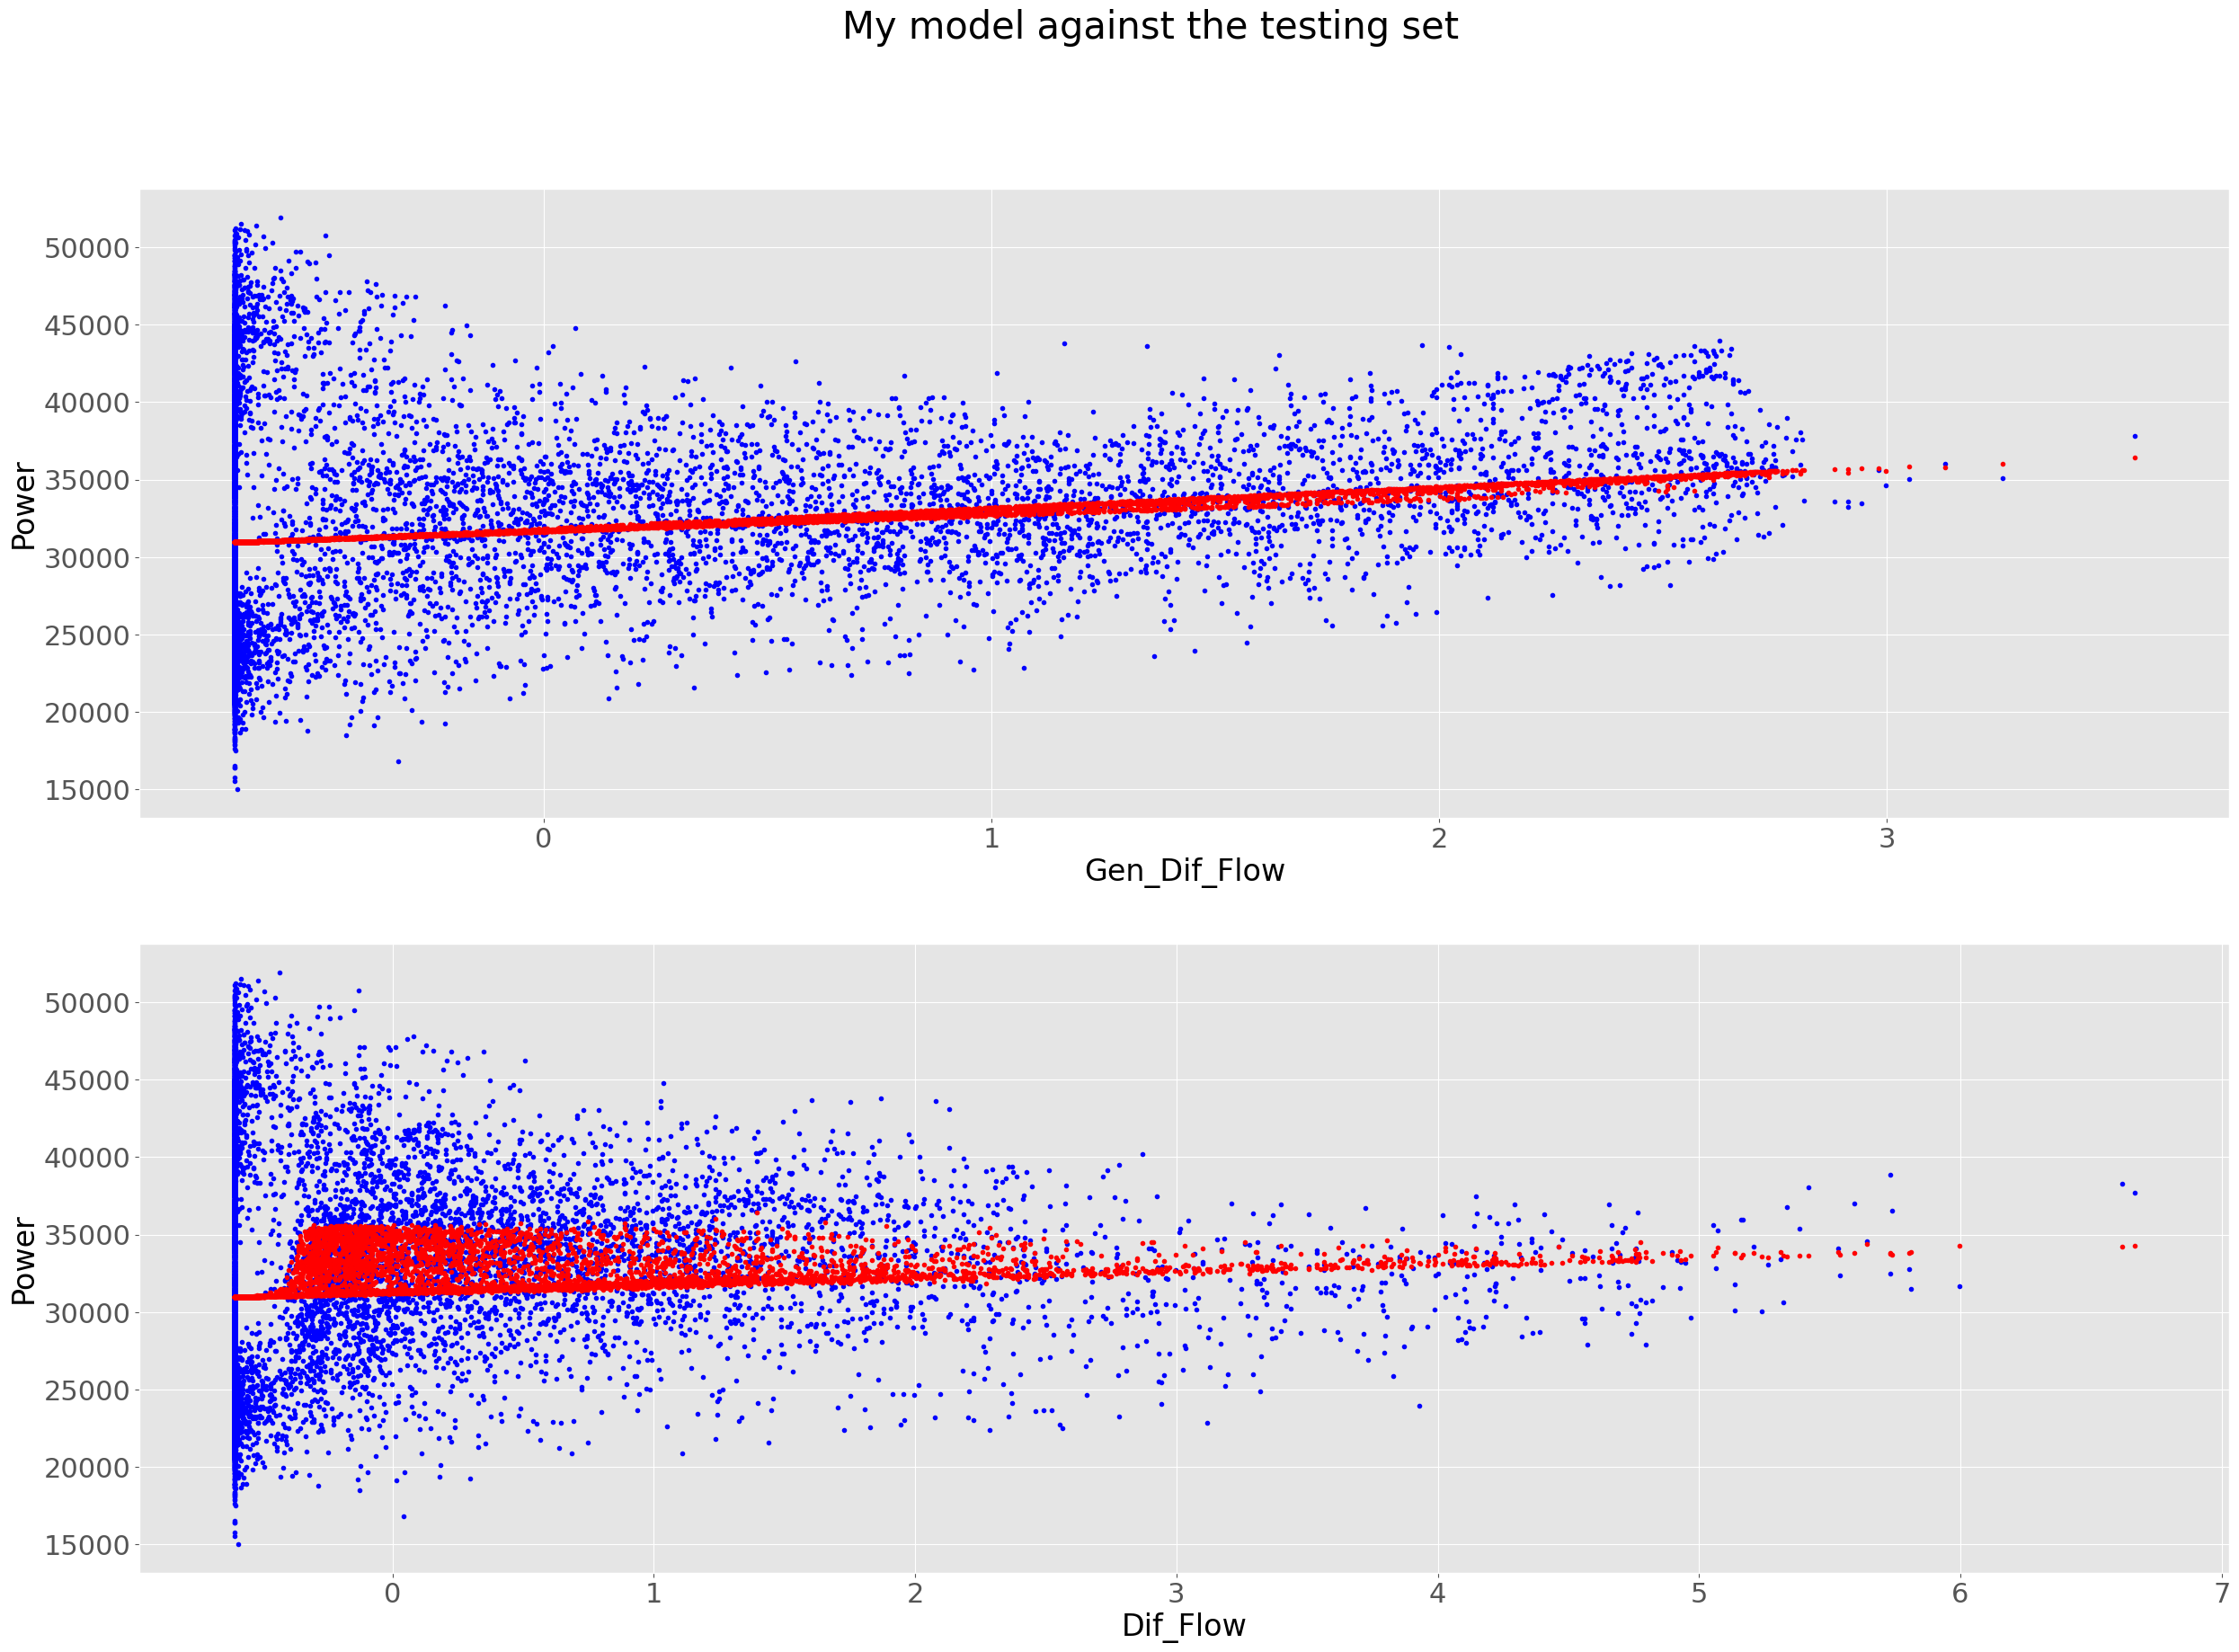

11 – Temperature, Humidity, General Diffuse Flows

My model's performance for training set

--------------------------------------

MSE is 40895370.320374526

R2 score is 0.198272768538851

Explained Variance score is 0.20463076677357672

--------------------------------------

My model's performance for test set

--------------------------------------

MSE is 40127247.21986673

R2 score is 0.20022080098249828

Explained Variance score is 0.20476545827893766

-------------------------------------- 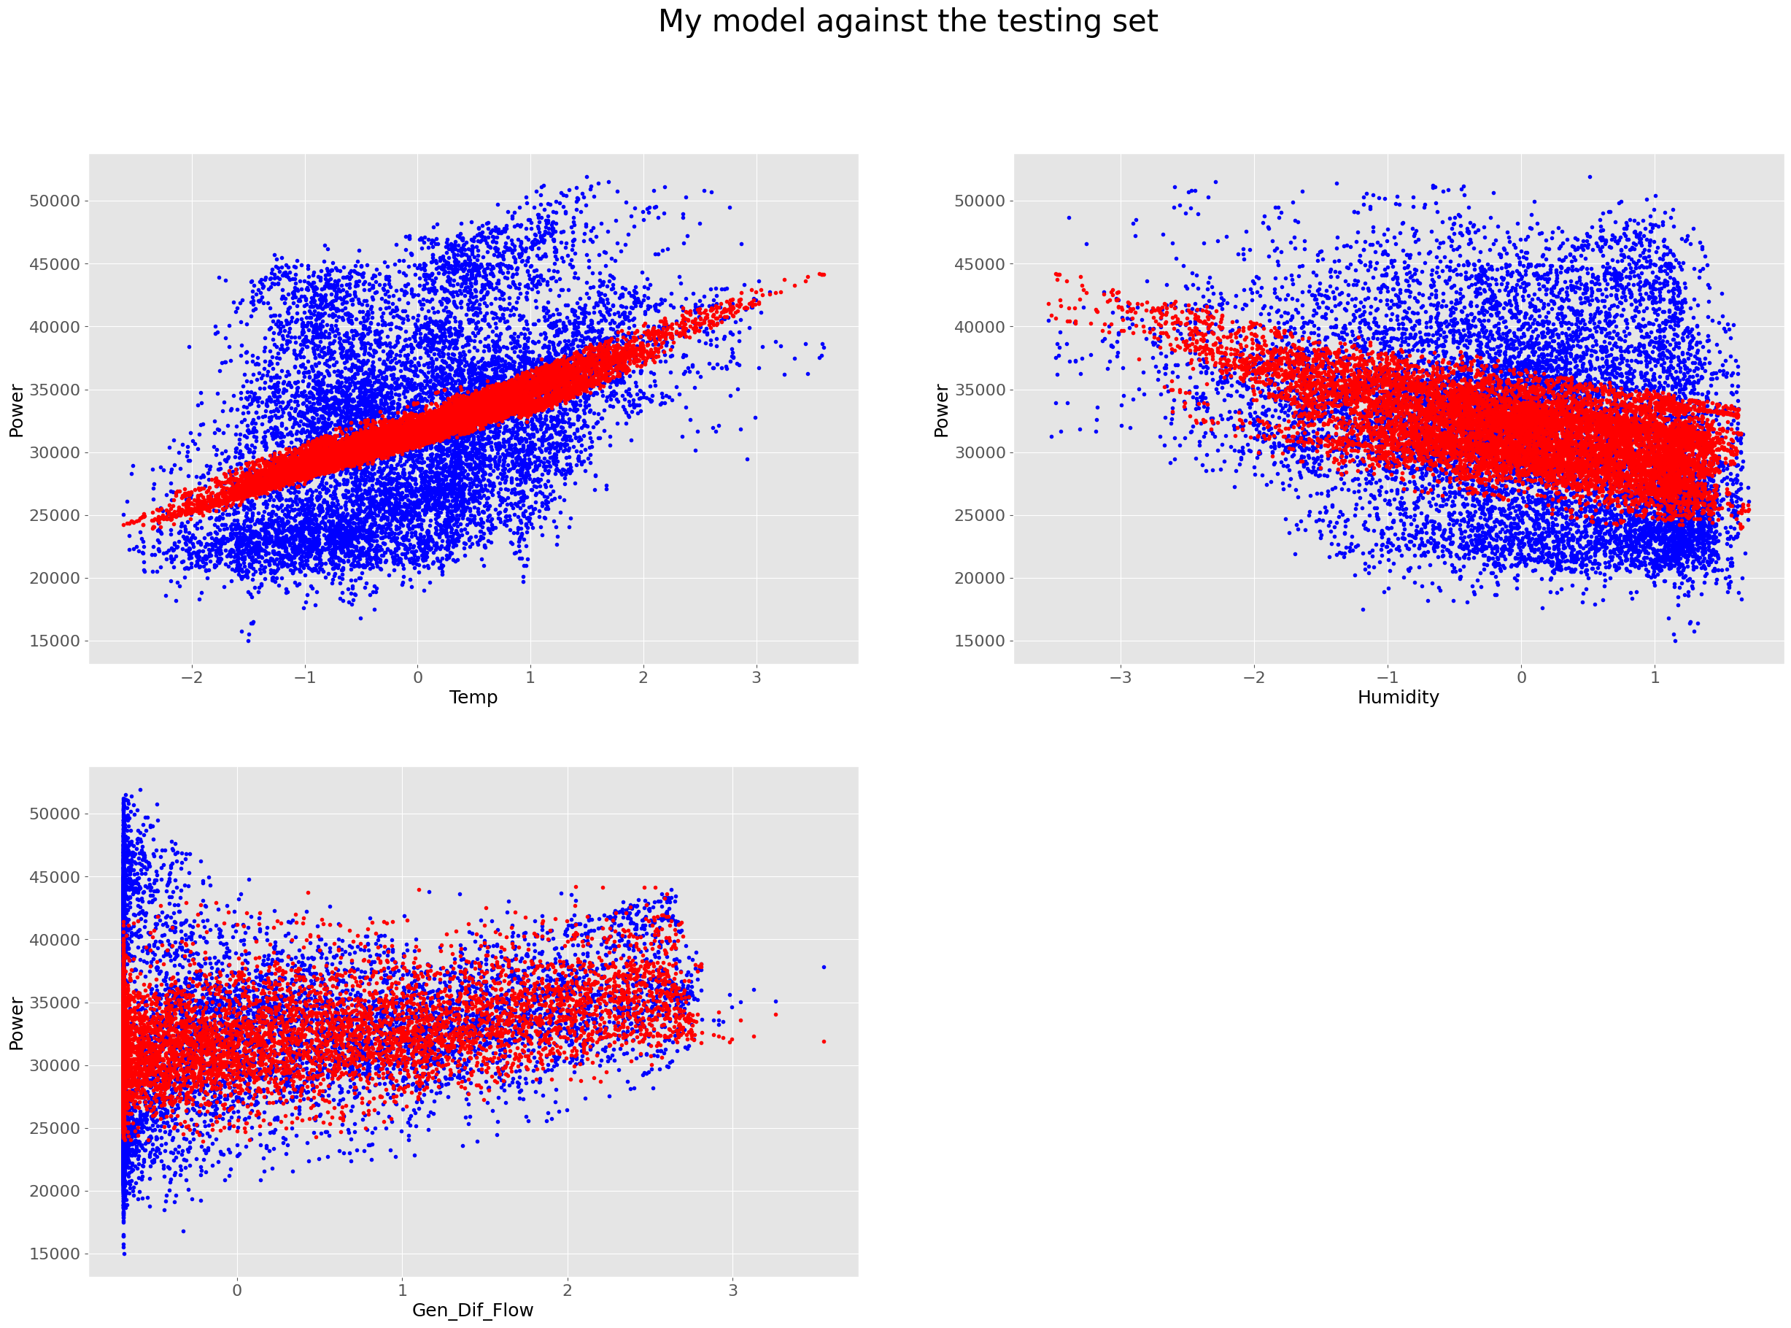

12 – Temperature, Humidity, Diffuse Flows

My model's performance for training set

--------------------------------------

MSE is 40968124.05470151

R2 score is 0.19684647872796324

Explained Variance score is 0.20319276679398768

--------------------------------------

My model's performance for test set

--------------------------------------

MSE is 40189578.98901508

R2 score is 0.19897846177767664

Explained Variance score is 0.20362262020983624

--------------------------------------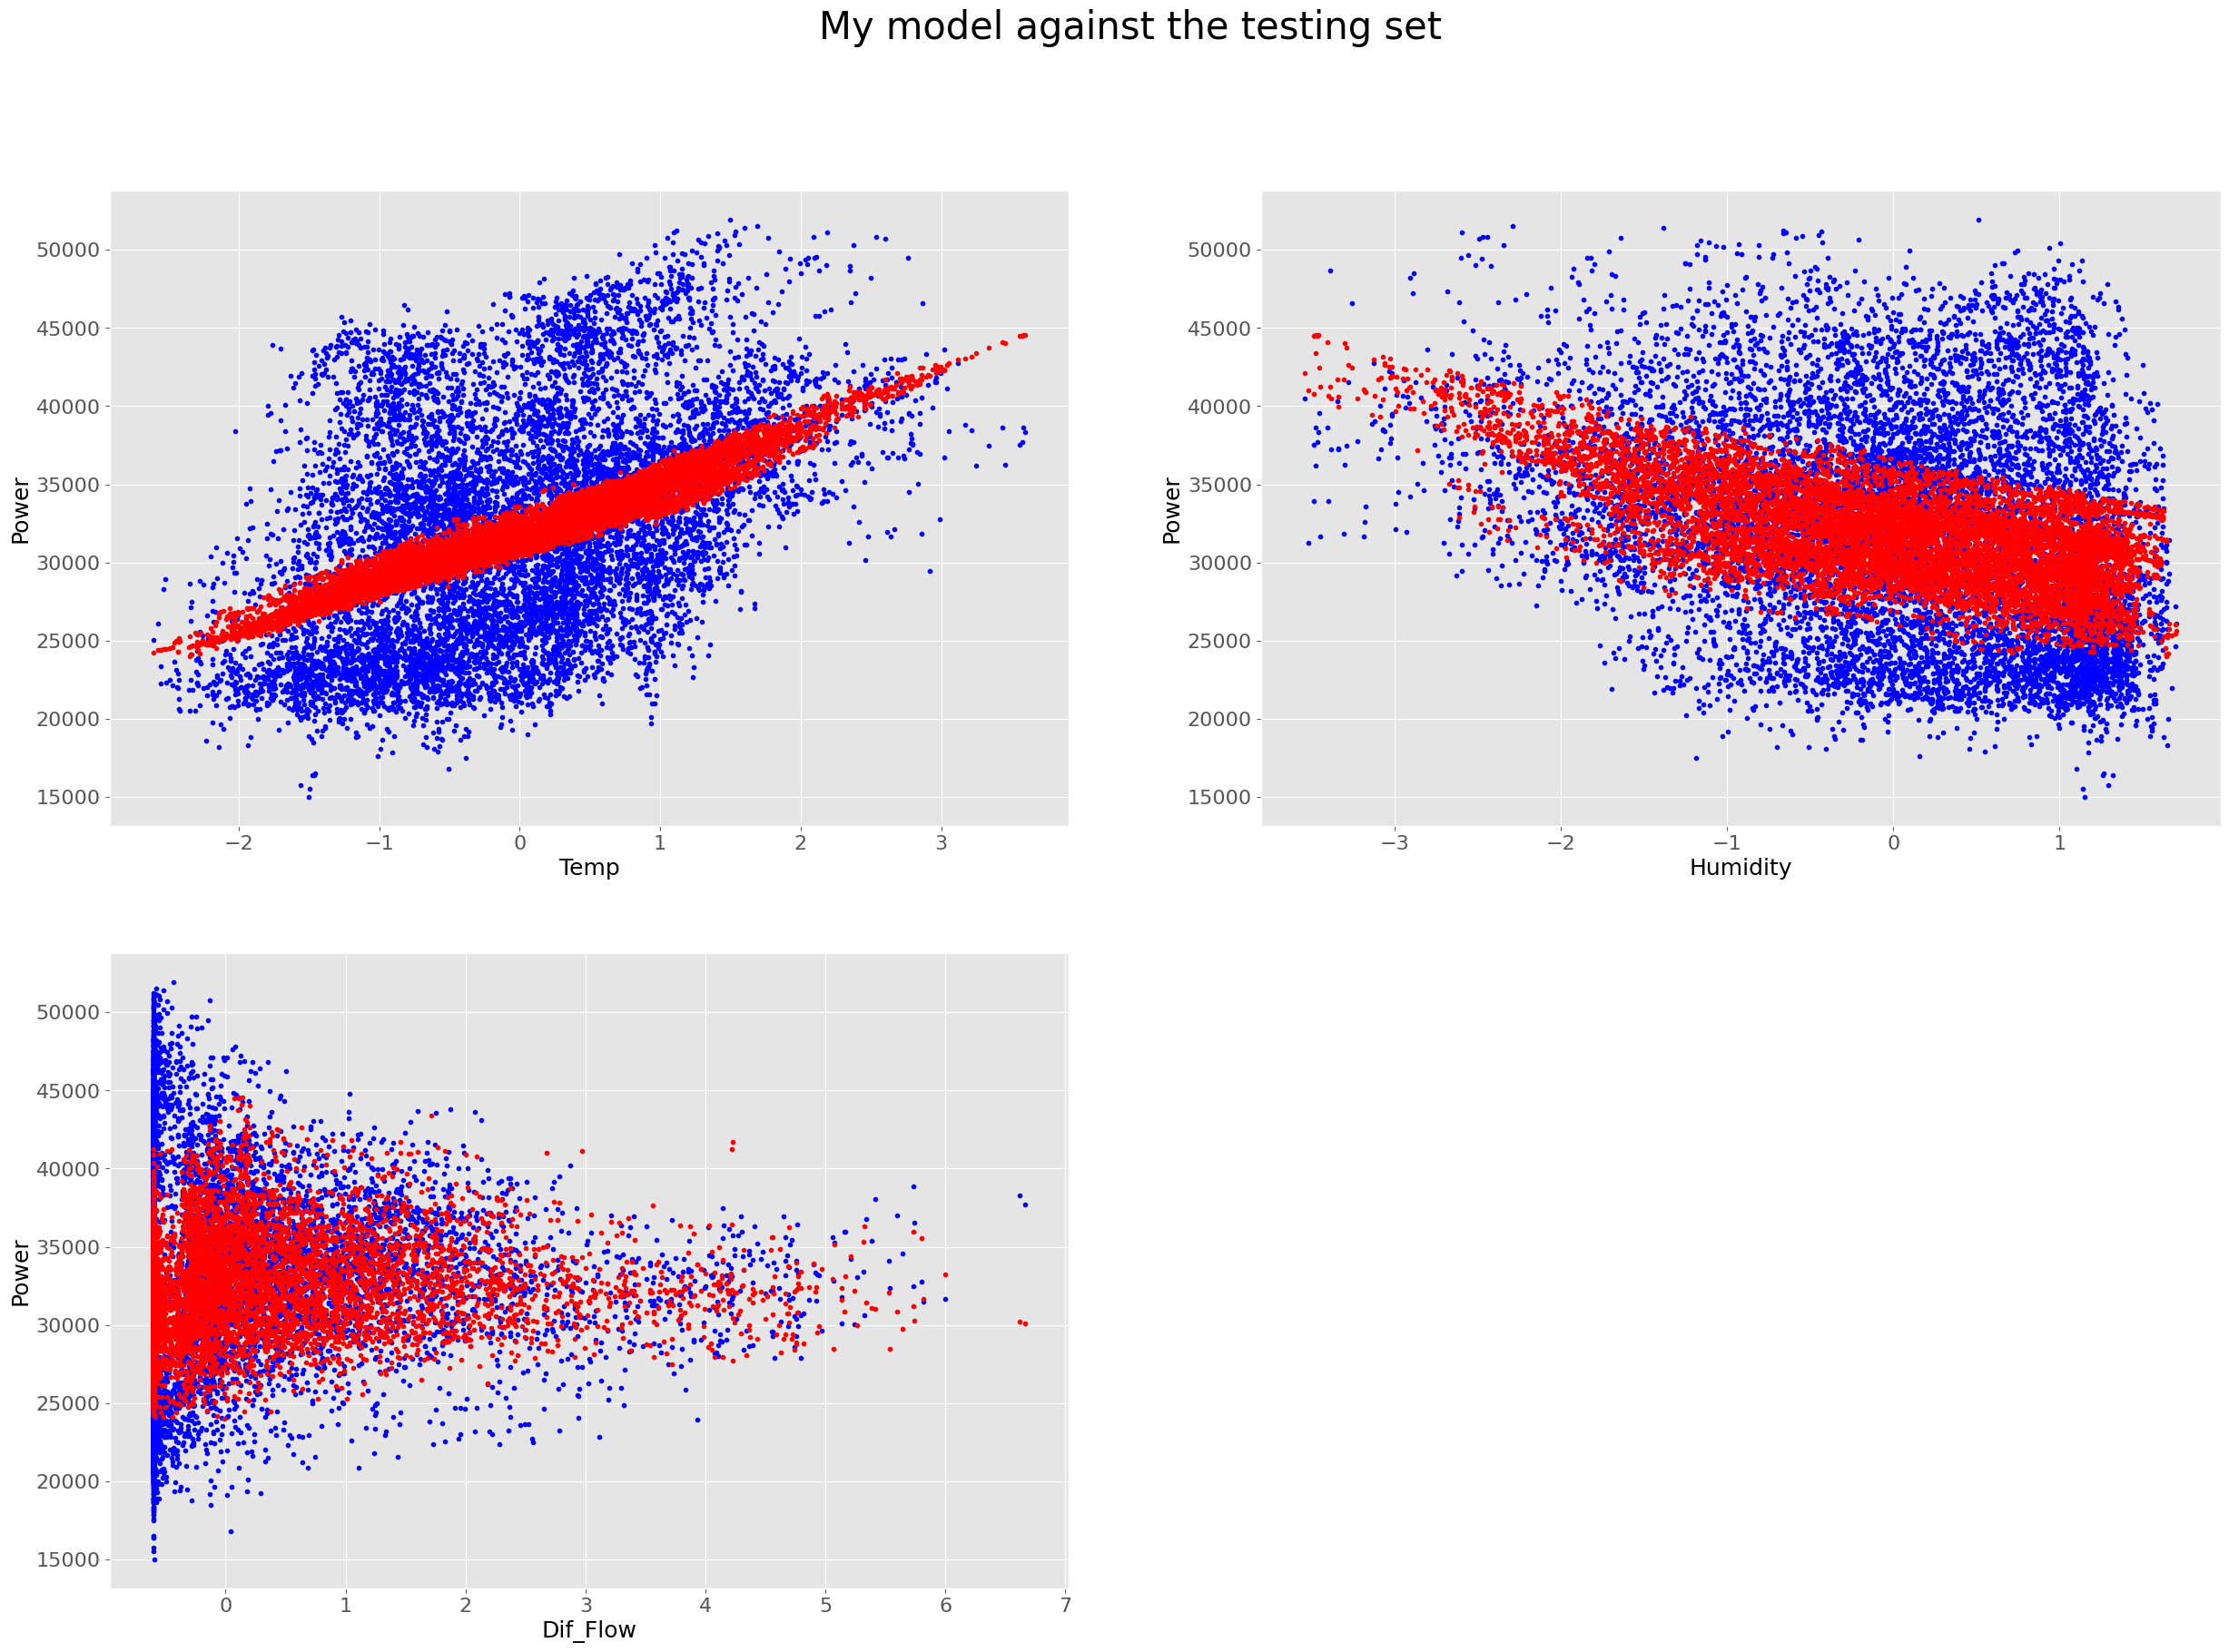

13 – Temperature, General Diffuse Flows, Diffuse Flows

My model's performance for training set

--------------------------------------

MSE is 41479092.77870807

R2 score is 0.18682926804490152

Explained Variance score is 0.19318378228412425

--------------------------------------

My model's performance for test set

--------------------------------------

MSE is 40714215.226455115

R2 score is 0.18852189725292134

Explained Variance score is 0.1930938997472743

-------------------------------------- 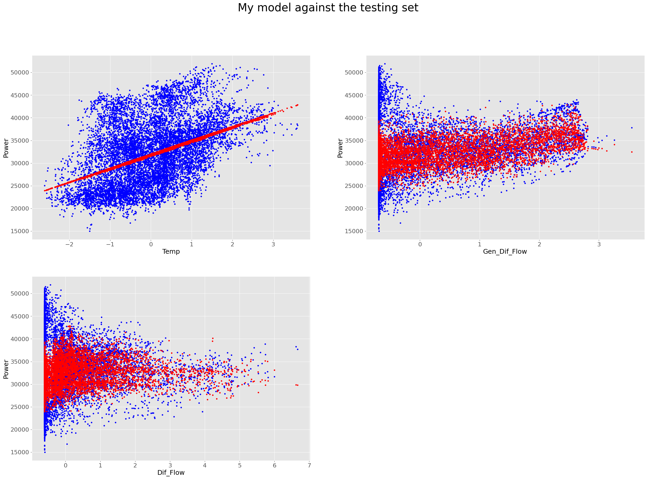

14 – Humidity, General Diffuse Flows, Diffuse Flows

My model's performance for training set

--------------------------------------

MSE is 46896813.69966271

R2 score is 0.080618360532417

Explained Variance score is 0.08696431665294801

--------------------------------------

My model's performance for test set

--------------------------------------

MSE is 46026496.07736445

R2 score is 0.08264242586489146

Explained Variance score is 0.08732106567161613

--------------------------------------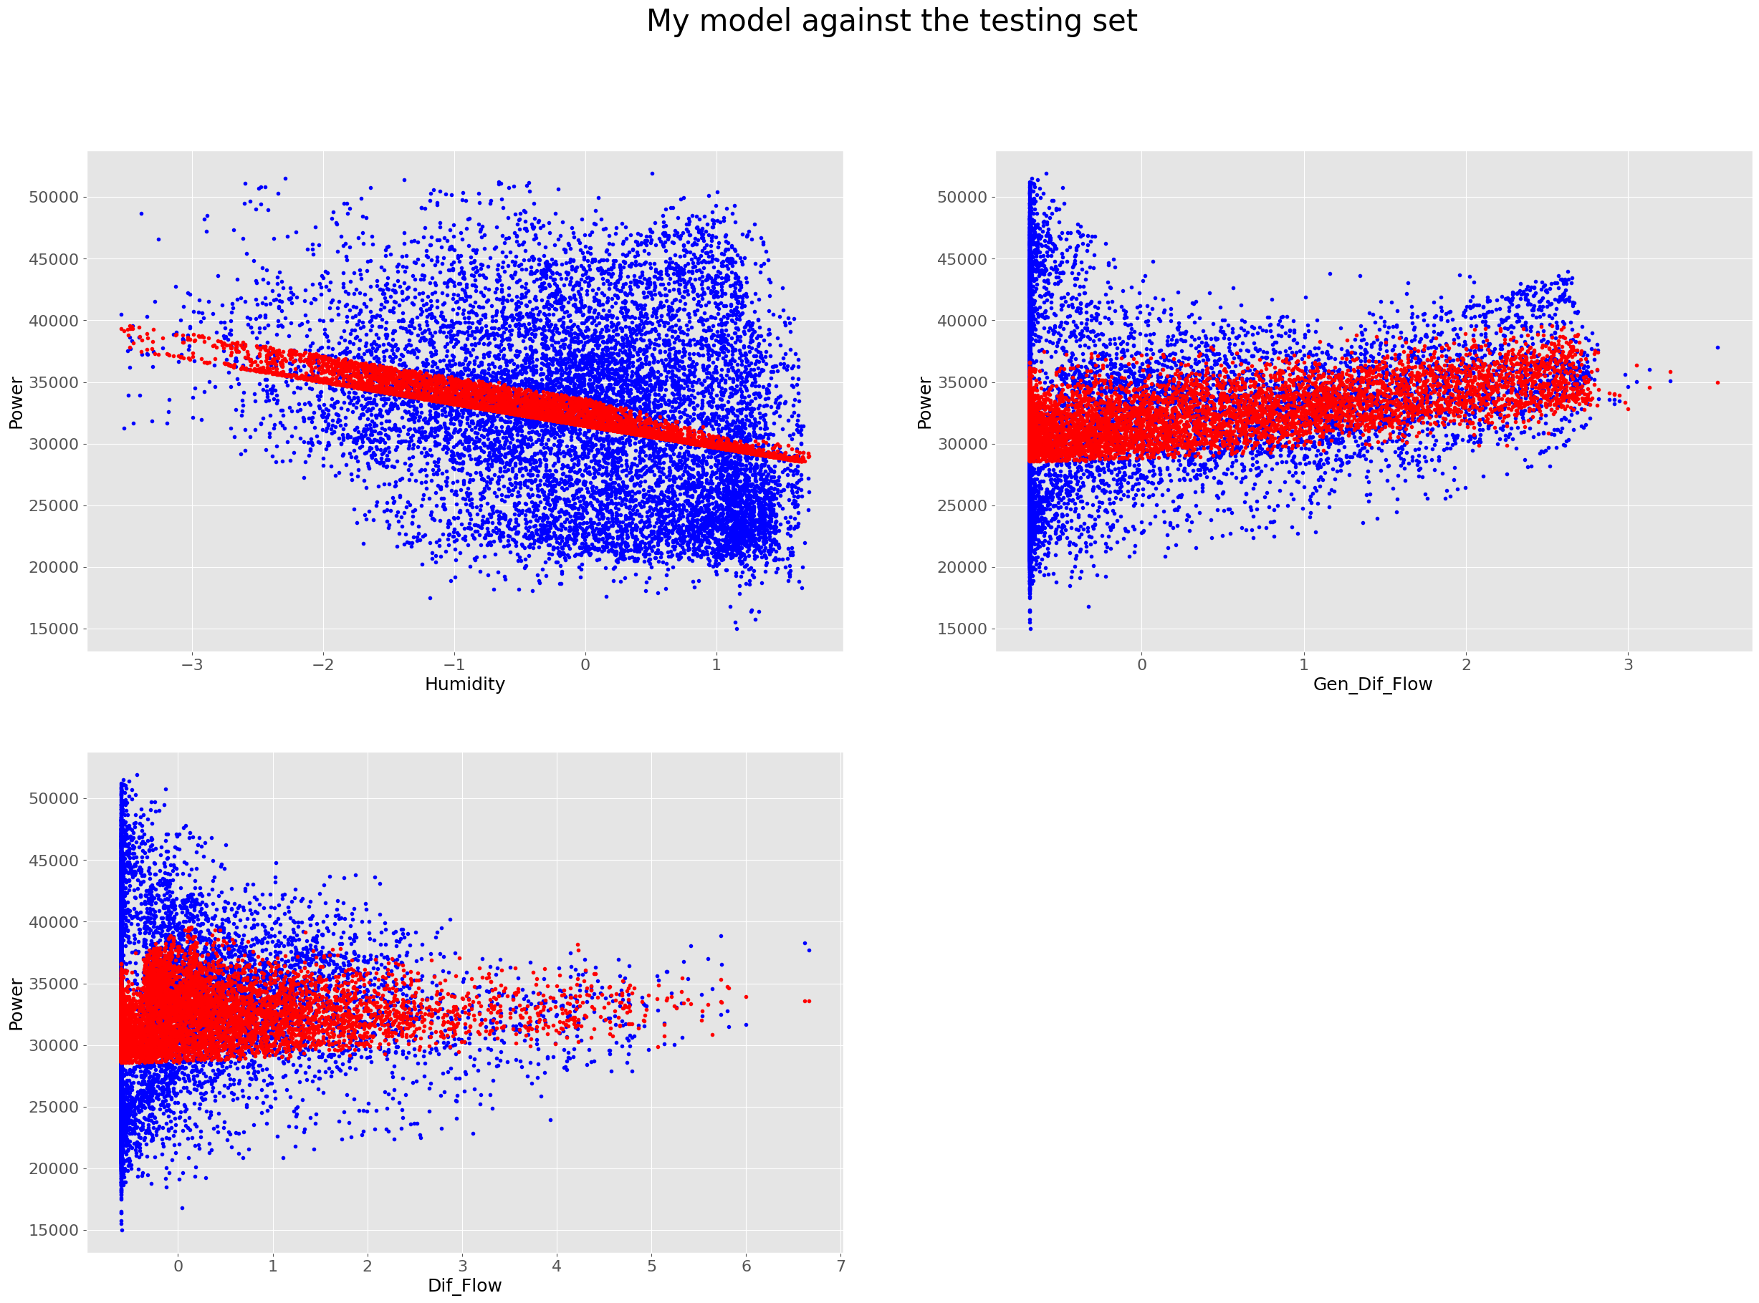

14 – Temperature, Humidity, General Diffuse Flows, Diffuse Flows

My model's performance for training set

--------------------------------------

MSE is 40908396.99313887

R2 score is 0.19801738906169508

Explained Variance score is 0.20437424060702192

--------------------------------------

My model's performance for test set

--------------------------------------

MSE is 40141030.665241145

R2 score is 0.19994608209034892

Explained Variance score is 0.2045390613770952

--------------------------------------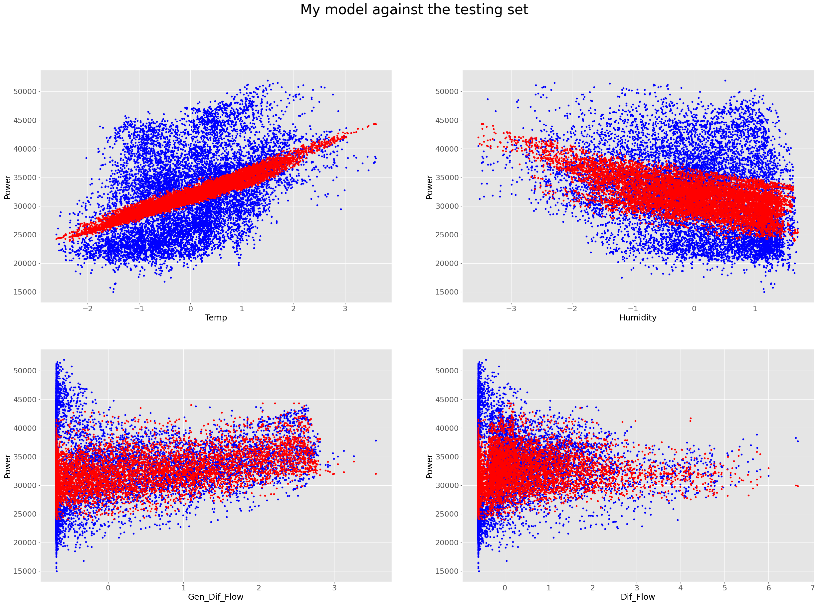

Analysis:

After comparing all the combinations of features the set of Temperature, Humidity, and General Diffuse Flows give the best fit for the test data. I’m not sure why, but the model tends to perform slightly better without accounting for Diffuse Flows.

The model's performance for test set

--------------------------------------

MSE is 40127247.21986673

R2 score is 0.20022080098249828

Explained Variance score is 0.20476545827893766

--------------------------------------



Trying to run the algorithm on Temperature, Humidity, and General Diffuse Flows with 0.001 learning rate and 1000 iterations.

My model's performance for training set

--------------------------------------

MSE is 60010831.392321676

R2 score is -0.17647345733601982

Explained Variance score is 0.19804879715059076

--------------------------------------

My model's performance for test set

--------------------------------------

MSE is 58546408.81707333

R2 score is -0.16689290178589067

Explained Variance score is 0.19872869047273822

--------------------------------------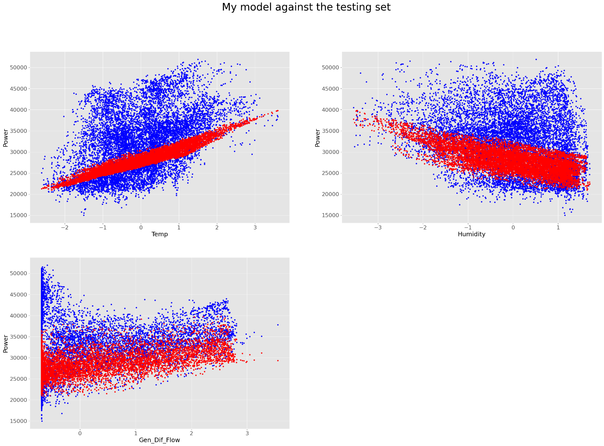

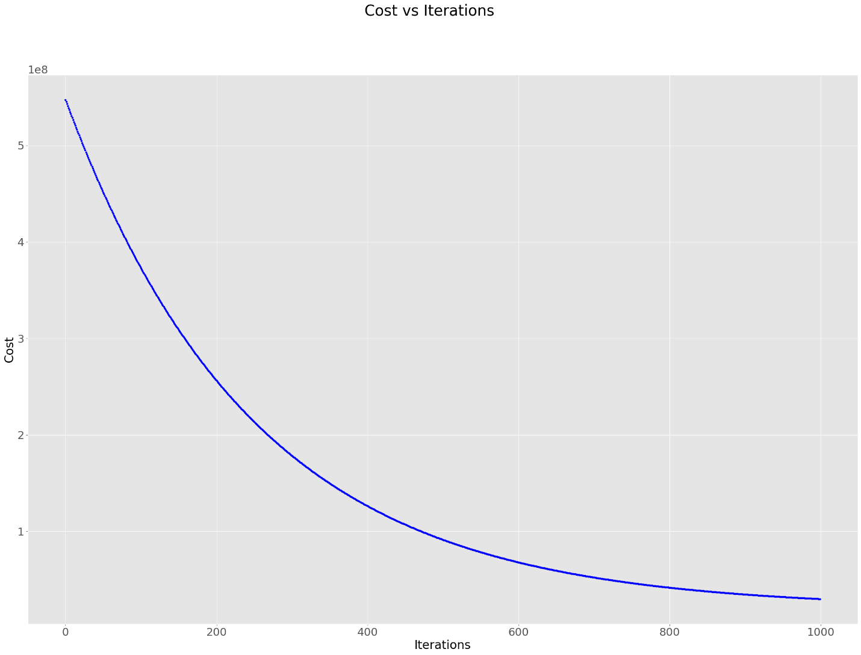

Not enough iterations, model is underfitted. Trying 3000 iterations:

My model's performance for training set

--------------------------------------

MSE is 40539246.520671114

R2 score is 0.20525434483359828

Explained Variance score is 0.20537949239746778

--------------------------------------

My model's performance for test set

--------------------------------------

MSE is 39871837.25689568

R2 score is 0.20531139627020445

Explained Variance score is 0.2053151388991591

--------------------------------------

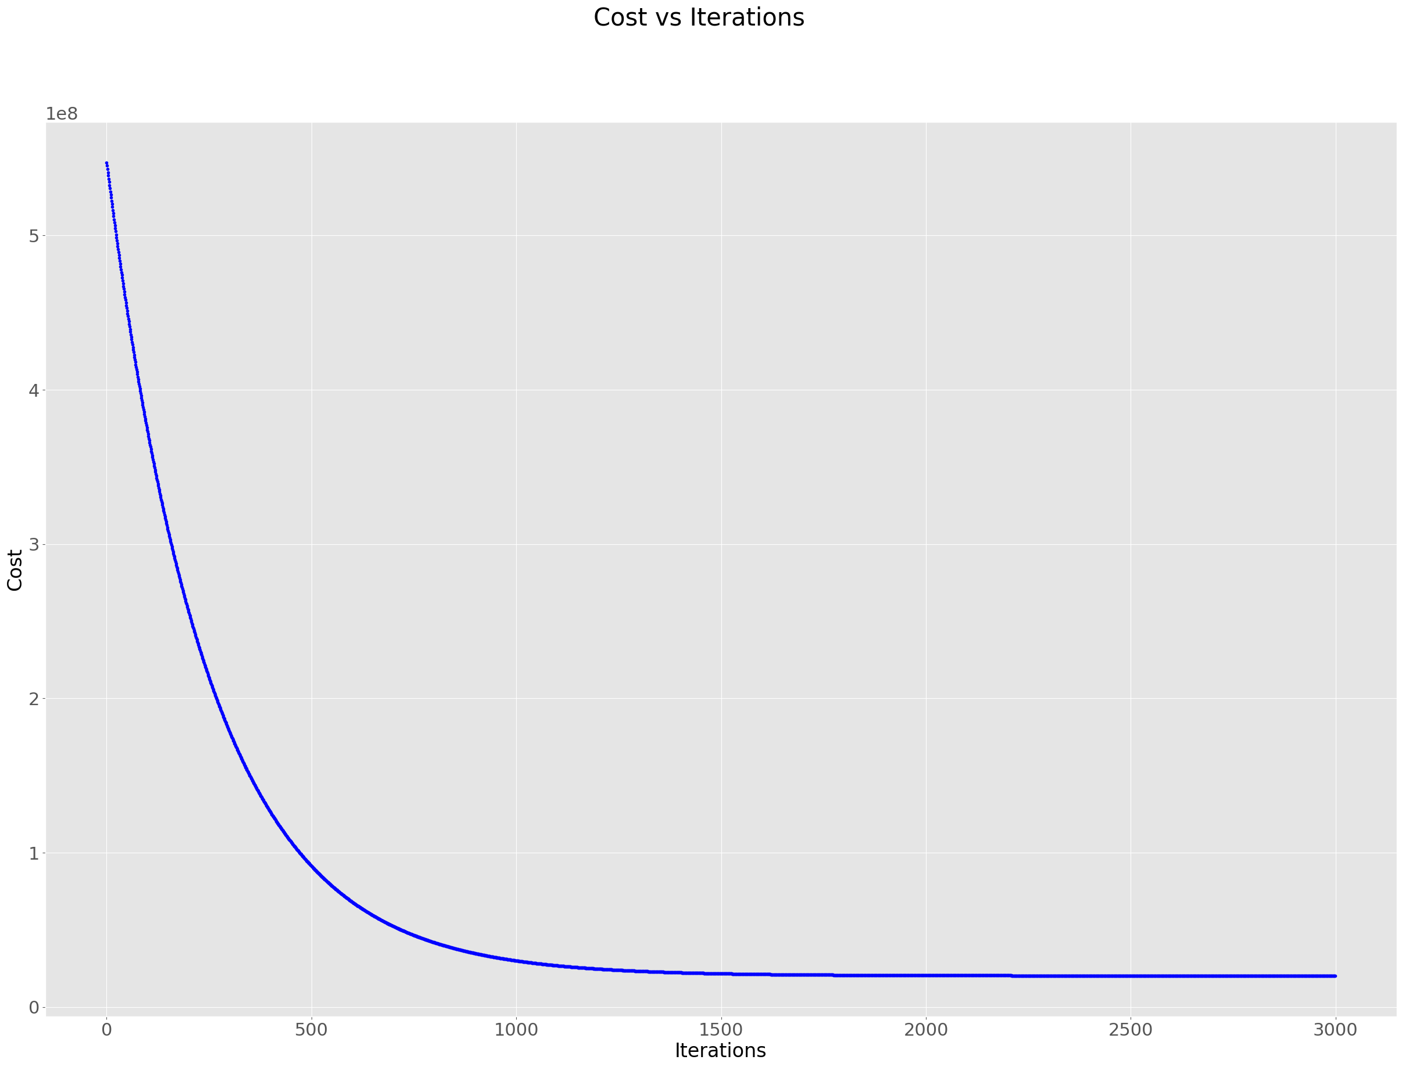

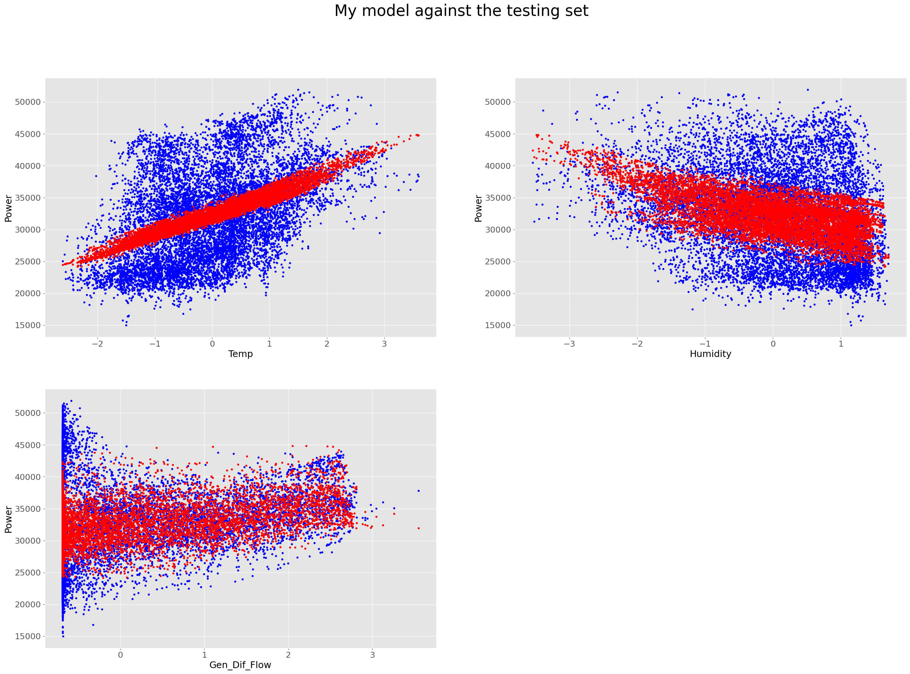

Lower learning rate requires significantly more iterations but also bring slight improvement to the model.

## Are you satisfied that you have found the best solution?

I’m sure that I found the best solution with the model that I have but I wouldn’t say that I’m happy with it. The dataset I used is not strictly linear, therefore I was not able to achieve a high accuracy of predictions using a linear regression model.

# Part 2

## Log

Running SKLearn SGDRegressor algorithm with iteration cap of 3000, default learning rate, and tolerance on the optimal features from part 1.

SKLearn model's performance for training set

--------------------------------------

MSE is 40537600.02745388

R2 score is 0.20528662326605485

Explained Variance score is 0.20528733014954514

--------------------------------------

SKLearn model's performance for test set

--------------------------------------

MSE is 39883049.90809369

R2 score is 0.2050879160712049

Explained Variance score is 0.20528126445346673

--------------------------------------

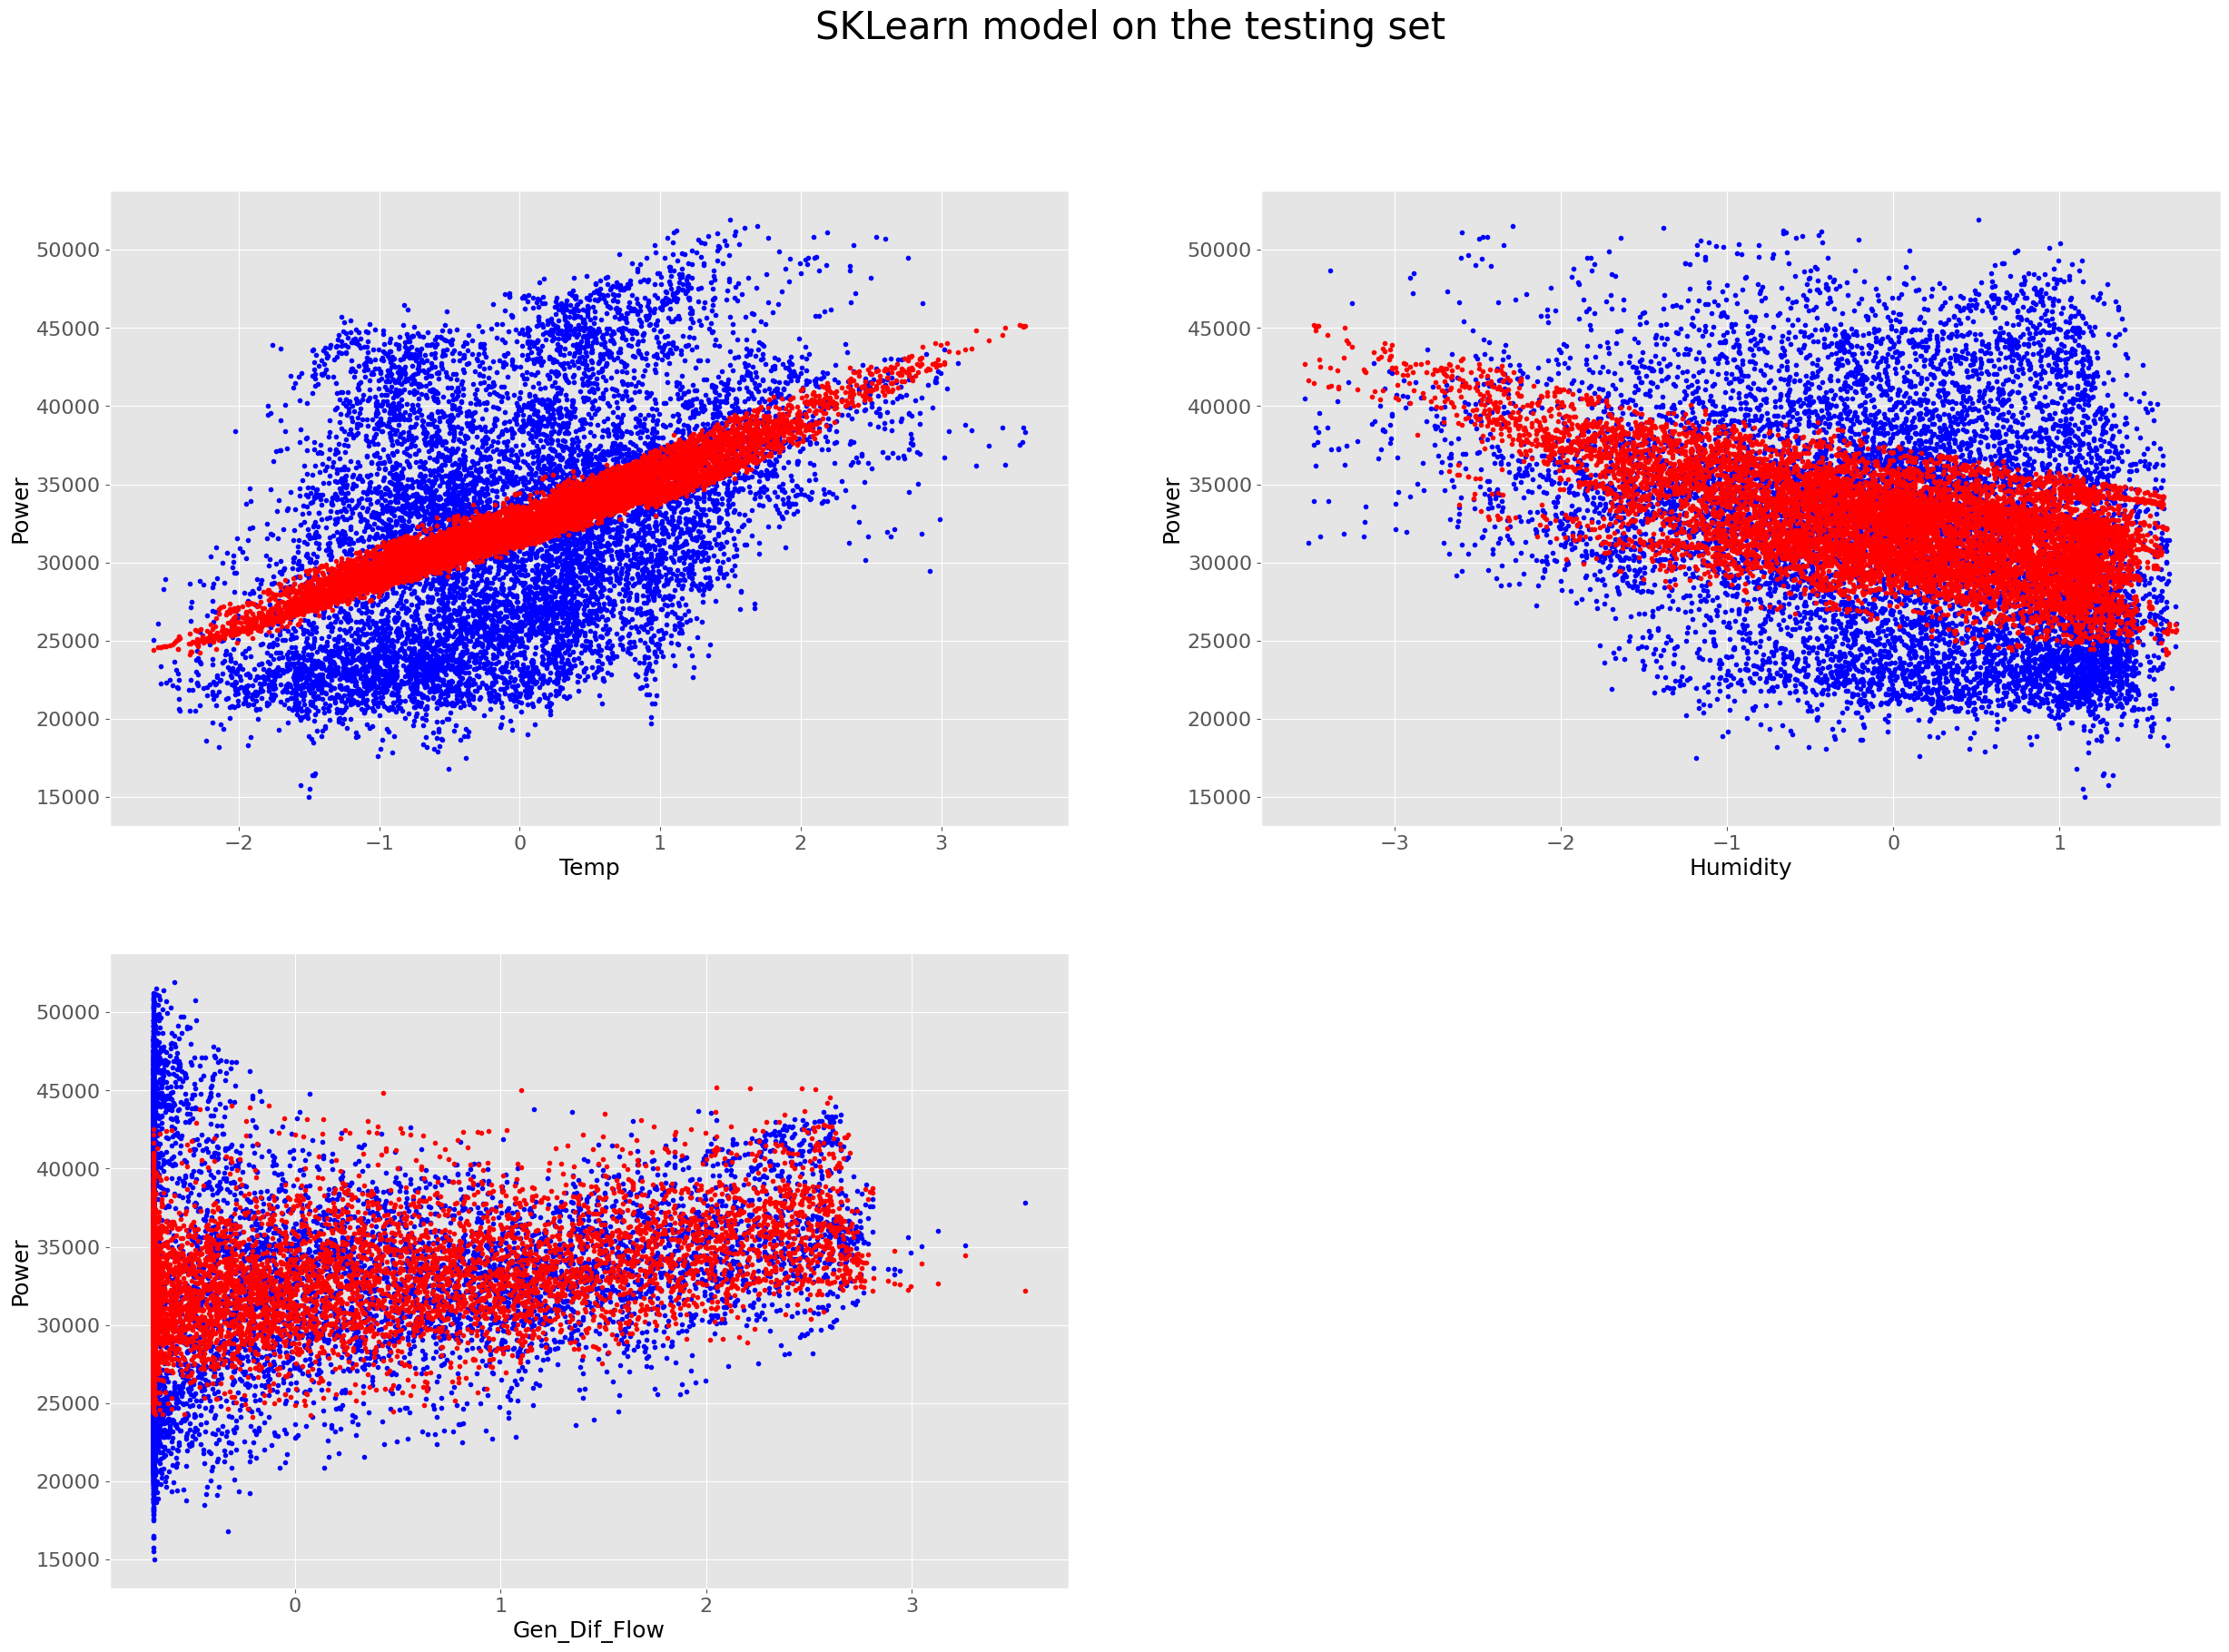

## Are you satisfied that you have found the best solution?

The results of SKLearn regression model are the same as my model so I feel satisfied with that.